低维钙钛矿：兼具高效率和稳定性的新型太阳能电池光吸收层候选材料
陈皓然¹，夏英东¹，陈永华¹，黄 维^{1,2,3}
（1 南京工业大学先进材料研究院，南京 211816；2 西北工业大学陕西柔性电子研究院，西安 710072；3 南京邮电大学信息材料与纳米技术研究院，南京 210023）

使用有机无机杂化钙钛矿材料作为光吸收层的钙钛矿太阳能电池自进入人们的视野以来，其制备工艺和器件结构不断得到优化，短短几年内效率取得了非常可观的增长。与此同时，这种基于三维钙钛矿材料的电池的缺点也越来越突出，尤其是材料的不稳定性，严重阻碍了其发展。低维钙钛矿材料具有有机胺层与无机层（金属卤化物钙钛矿晶体）之间相互交替的低维（层状）结构，其中被有机胺隔开的独立钙钛矿层中八面体的层数n越小，钙钛矿越接近二维结构。相比传统三维钙钛矿结构，低维钙钛矿材料应用于光伏器件具有两大优势：（1）耐湿性、光热稳定性大大增强；（2）可以通过改变n和插入的有机胺的种类来实现光学及电学性质的可调性。
然而，低维钙钛矿具有较大的光学带隙，有机胺的引入降低了载流子迁移率，导致低维钙钛矿电池的效率明显低于三维钙钛矿电池。因此，近三年来除研究钙钛矿层数对材料性质和器件性能的影响外，研究者们主要从选择合适的有机胺和优化薄膜制备工艺方面不断尝试，并取得了丰硕的成果，在充分发挥低维钙钛矿稳定性优势的同时大幅提升了器件效率。目前，低维钙钛矿太阳能电池的光电转换效率已由2014年的4.37%跃升至13.7%。
在较高效率的低维钙钛矿太阳能电池中已取得成功应用的有机胺类包括苯乙胺（PEA）、正丁胺（n-BA）、异丁胺（iso-BA）、聚乙烯亚胺（PEI）等。其中PEA应用得最早；n-BA是运用在目前为止最高效的低维钙钛矿电池中的有机胺；而PEI插层形成的低维钙钛矿拥有相对更小的光学带隙和更高的耐湿性，但载流子的传输会受到更大的限制。低维钙钛矿薄膜的制备起初主要采用简单的一步旋涂法，但此法所得的低维钙钛矿平行于基底生长，器件效率很低。近两年的研究工作将基底预热、浸泡、反溶剂滴加等手段引入到钙钛矿旋涂工艺中，实现了低维钙钛矿优先垂直基底生长，为突破低效率瓶颈提供了可能。此外，以三维钙钛矿为基础，以有机胺为添加剂，制得的二维和三维混合的钙钛矿结构，也可以实现器件效率和稳定性的双提升。
本文归纳了低维钙钛矿光伏器件的研究进展，分别对低维钙钛矿的分子结构、插入的有机胺的选择、钙钛矿薄膜的制备方法等进行介绍，分析了低维钙钛矿太阳能电池面临的问题并展望其前景，以期为制备稳定和环境友好的新型钙钛矿太阳能电池提供参考。
关键词：低维钙钛矿 太阳能电池 有机胺 层状钙钛矿 光伏器件
中图分类号： 文献标识码：A
通信作者：陈永华，iamyhchen@njtech.edu.cn

Low-dimensional Perovskites: a Novel Candidate Light-harvesting Material for Solar Cells that Combines High Efficiency and Stability
CHEN Haoran¹, XIA Yingdong¹, CHEN Yonghua¹, HUANG Wei^{1,2,3}
1 Key Laboratory of Flexible Electronics & Institution of Advanced Materials, Jiangsu National Synergetic Innovation Center for Advanced Materials, Nanjing Tech University (Nanjing Tech), Nanjing 211816, China; 2 Shaanxi Institute of Flexible Electronics), Northwestern Polytechnical University, Xi'an 710072, China; 3 Key Laboratory for Organic Electronics & Information Displays, and Institute of Advanced Materials, Nanjing University of Posts and Telecommunications, Nanjing 210023, China

Since the emergence of organic-inorganic hybrid perovskite materials as light harvesters, the perovskite solar cells have attained a considerable efficiency improvement due to notable achievements in optimizing the fabrication process and device structure, while nevertheless been suffering increasingly serious challenges, especially instability. Layered (low-dimensional) perovskite materials are constructed based on a periodical (or quasi-periodical, or hybridized) structure which is composed of alternate layers of organic amines and metal halide perovskite crystals. The layered structure approximates to a two-dimensional structure whilst the number (n) of planes, which consist of the pyramids’ squares of the perovskite octahedrons, within one separated perovskite layer approaches 1. For photovoltaic application, these low-dimensional perovskite structures have two advantages compared to their three-dimensional counterparts. I. remarkably enhanced moisture resistance and thermal stability, II. tunable optical and electrical characteristics by varying n and selecting different organic amines.
On the other hand, poor carrier mobility (a consequence of the inhibition of out-of-plane charge transport by the organic amine cations) and wide band gap contribute to a far lower efficiency of low-dimensional perovskite solar cell than three-dimensional perovskite device. This urges intensive research endeavors to seek favorable organic amines and optimize perovskite film fabrication process, aiming at boosting photovoltaic efficiency while exploiting layered perovskite’s stability. And in the past three years, impressive strides have been made in promoting the low-dimensional perovskite solar cells, with a giant leap in the reported power conversion efficiency (PCE) from 4.37% to 13.7%.
Phenethylamine (PEA), n-butylamine (n-BA), isobutylamine (iso-BA), polyethylenimine (PEI), etc. have been found to be satisfactory as the hydrophobic amine interlayers for relatively-high-efficiency layered perovskite solar cells. PEA is the first to be involved in the attempts, and the n-BA-intercalated perovskite hold the currently highest efficiency of this new type of photovoltaic devices. PEI intercalation appears to result in narrower band gap and higher moisture resistance, but also leads to a larger inhibition to the carrier transport. Although one-step spin coating provides a facile route to obtain layered perovskite films, this method will cause the horizontal growth (i.e. interlayers parallel to substrate) of the layered structure and in consequence, an extremely low cell efficiency. Works in the past two years have established a new avenue to overcome the low-efficiency bottleneck, by introducing various techniques into the spin coating process, e.g. hot casting, immersion (in short-chain amines), antisolvent dripping, all of which have successfully achieved the preferential out-of-plane alignment of the inorganic perovskite layers. Besides, researchers also have demonstrated that the 2D-3D hybrid perovskite structures, which can be constructed on the basis of 3D perovskite with the presence of organic amine additives, can gain improvements in terms of both efficiency and stability.
This review offers a retrospection of the research efforts with respect to the layered (low-dimensional) perovskite photovoltaic devices, and provides elaborate descriptions about the structure of low-dimensional perovskite, the selection of the intercalating organic amines, and the film fabrication process. We then pay attention to the problems confronting the current state-of-the-art low-dimensional perovskite solar cells. We have confidence that the low-dimensional perovskite solar cells have a bright future in the development and innovation of stable and environmental-friendly photovoltaic devices.
Keywords: low-dimensional perovskite, solar cell, organic amine, layered perovskite, photovoltaic device
Correspondence: Yonghua Chen, iamyhchen@njtech.edu.cn

0 引言
钙钛矿材料作为目前最火热的新型光吸收材料，是人们近几年一直在关注和研究的对象之一，其中有机无机杂化钙钛矿材料发展迅猛。作为一种光学和电学性质显著的半导体材料，它具有高的消光系数^{[1]}、高的载流子迁移率^{[2]}、小的激子结合能^{[3]}以及易溶液制造加工^{[4]}等优点，被研究者们广泛用于各种结构的太阳能电池中。经过对薄膜制备^{[5-9]}和器件结构^{[10]}的不断优化，有机无机杂化钙钛矿太阳能电池的效率在短短几年内从最初的3.81%^{[11]}已增长到如今的22.1%^{[12]}。
随着钙钛矿太阳能电池取得突破性进展，其缺点也更加突出，尤其是材料的不稳定性已成为此种电池发展的最大绊脚石^{[13-14]}。传统的三维钙钛矿结构如图1(a)所示，………………………使其在光伏器件中可以获得前所未有的高稳定性。
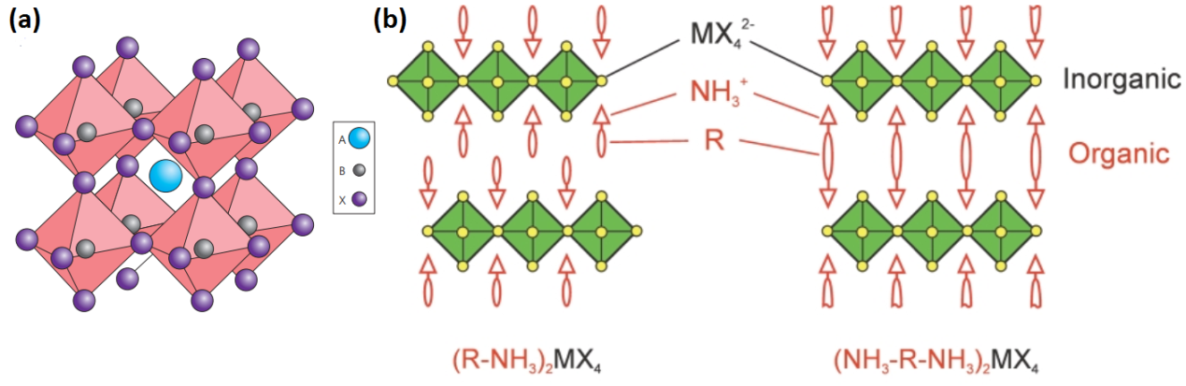
图1 (a)三维钙钛矿晶体结构^{[21]}；(b)使用不同有机胺离子插层所形成的二维钙钛矿结构^{[22]}
Fig.1 The basic structures of (a) three-dimensional perovskites ^{[21]} and (b) two-dimensional layered perovskites intercalated with two different types of organic amine cations ^{[22]}

1 低维钙钛矿分子结构
常见的低维钙钛矿的通式为(R-NH₃)₂A_{n-1}M_{n}X_{3n+1}，其中R-NH₃代表插层的有机胺离子，A对应于三维钙钛矿中原有的A位阳离子，M为金属阳离子，X为卤素阴离子，n表示每一层分开的钙钛矿层中八面体的层数，也统称为低维钙钛矿的层数。插层的有机胺不仅可以是单胺，还可以是双胺甚至多胺(Polyamine)，选择具有不同氨基数目的有机胺，就会形成不同的层间结构（见图1(b)），若选择双胺，那么结构通式就变成(NH₃-R-NH₃)A_{n-1}M_{n}X_{3n+1}。从图2可以看出：当n=1时，无机层中的八面体只有一层，这时可以将n=1时的低维钙钛矿称作二维钙钛矿结构；随着n的增大，无机层逐渐变厚，这时的低维钙钛矿（n≥2）也可以称为准二维钙钛矿结构；当n逐渐增大到无穷时（n=∞），无机层已经厚到可以将有机胺层完全忽略，这样无穷层数的钙钛矿就趋近于三维钙钛矿结构。从晶向上来划分，不同的晶向有不同的结构通式^{[23]}：常见的用于太阳能电池中的低维钙钛矿(R-NH₃)₂A_{n-1}M_{n}X_{3n+1}为<100>晶向，此类型的低维钙钛矿在n较小（n≤10）时也称作Ruddlesden-Popper结构钙钛矿；其他的晶向还有<110>^{[24]}、<111>^{[25]}。低维钙钛矿具有不同的晶向，主要是由于不同结构的有机胺与无机层的自组装方式不同。
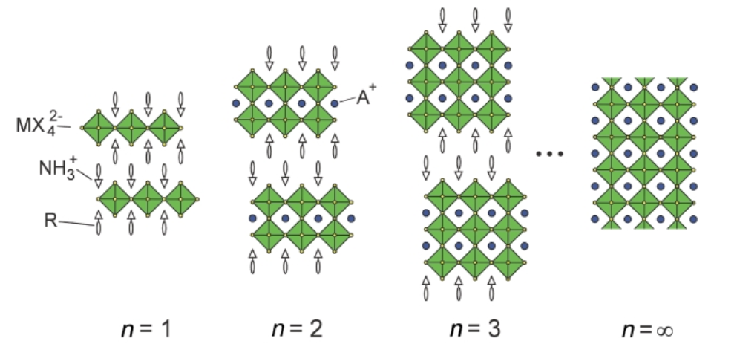
图2 不同n值的(R-NH₃)₂A_{n-1}M_{n}X_{3n+1}钙钛矿分子结构示意图^{[22]}
Fig.2 The molecular structures of the (R-NH₃)₂A_{n-1}M_{n}X_{3n+1} perovskites differing in n value ^{[22]}

………………………………………………………………………………………………………………………………………
(为方便进行示例，以下使用了来自其他文章中的公式)
XXXXXXXXX如式（1）所示：
(αhν)²=A(hν–E_{g}) （1）
式中：α为吸收系数；hν为入射光子的能量（其中h为Plank常数，ν为光频率）；A为常量；E_{g}为材料的光学带隙。
………………………………………………………………………………………………………………………………………

2 有机胺的选择和无机层中钙钛矿层数的优化
最先制备出的较高效率的低维钙钛矿太阳能电池中运用了苯乙胺（PEA）作为有机阻挡层（见图3(b)）。Smith 等^{[26]}将n=3的钙钛矿薄膜(PEA)₂(MA)₂Pb₃I₁₀与最常见的三维MAPbI₃钙钛矿进行比较，两者带隙的实测结果分别为2.1 eV和1.61 eV，两者的薄膜形貌和薄膜性质也有很大差别。此外，Smith等对固体和粉末低维钙钛矿进行了粉末X射线衍射（PXRD）分析，根据两者测试结果之对比发现，粉末钙钛矿存在少量对应于1、2、4、5层数的钙钛矿的特征峰，说明所得的钙钛矿并非完全只存在n=3的结构，而是掺杂了少量其他层数结构的低维钙钛矿。………………………………
………………………………………………………………………………………………………………………………………
………………………Quan等^{[18]}试图把三维钙钛矿的维度降低，以得到较稳定的钙钛矿结构。计算表明，对传统的三维钙钛矿而言，相对于形成钙钛矿晶体，分解成PbI₂和MAI（分子式为CH₃NH₃I）会更加稳定一些，其中甲胺阳离子（MA⁺）的亲水性和挥发性使得MAPbI₃更容易因湿度和热量而发生降解，并且钙钛矿的分解也不是在内部自发进行，而是由表面开始。而有机胺层间存在范德华力，若要从钙钛矿中去除PEAI，所需的能量就比仅去除MAI要高，薄膜的解吸附速率大大降低，从而使钙钛矿的分解速率降低为原来的1/1 000。从图4可以看出，如预期一样，降低维度的钙钛矿无论是薄膜还是器件都展现出了高稳定性，并且足够厚的层数（n=60）和可降低带隙的甲脒使得电池的认证效率依旧达到了15.3%。
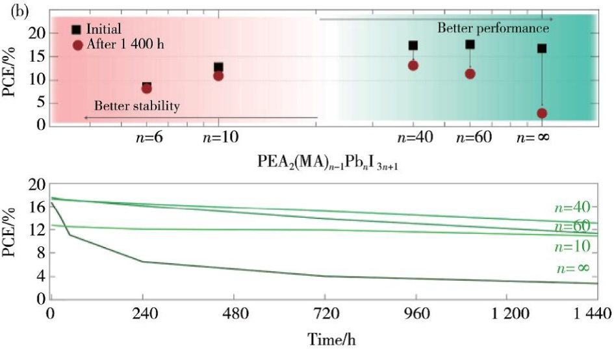
图4 (a)不同n值的(PEA)₂(MA)_{n-1}Pb_{n}I_{3n+1}光伏器件的效率分布^{[18]}；(b)器件性能和稳定性随层数变化的示意图^{[18]}；(c)不同层数的器件随时间推移的效率演变^{[18]}
Fig.4 (a) The PCEs for (PEA)₂(MA)_{n-1}Pb_{n}I_{3n+1} perovskite device with different n values ^{[18]}; (b) device performance and stability as functions of n value ^{[18]}; (c) performance evolution of the devices with different n values as a function of time ^{[18]}

3 薄膜制备
(为方便进行示例，以下小节标题为虚构内容)
3.1 基底预热
………………………………………………………………………………………………………………………………………
3.2 反溶剂滴加
………………………………………………………………………………………………………………………………………
(为方便进行示例，以下使用了来自其他文章中的表格)

表1 二维材料的各向异性总结
Table 1 Brief summary of anisotropic properties of 2D materials
Anisotropic property | 2D material | Application | Prospect
Raman spectra | Black phosphorus, ReS₂, ReSe₂, MoTe₂, WTe₂ | Determining crystallographic orientation; Analyzing atom-atom interaction | i) Anisotropic modulation by certain means;  ii) Anisotropies of some unmentioned materials (e.g. WS₂, antimonene) are worthy of study, also quite a few materials’ anisotropic properties are undiscovered;  iii) Developing polarized devices inspired by 2D materials’ anisotropies;  iv) Optimizing devices’ performances by exploiting 2D materials’ anisotropies
Photoluminescence (PL) spectra | Black phosphorus | Polarized photodetectors
Second harmonic generation (SHG) spectra | MoS₂, MoTe₂ | Determining crystallographic orientation and layer-number uniformity; nonlinear effects (frequency doubling, four-wave mixing, etc.)
Electric conductivity | MoS₂, black phosphorus, ReS₂ | Polarized optoelectric devices, artificial neural systems
Thermal conductivity | MoS₂, black phosphorus, WTe₂, arsenene | Polarized thermoelectric devices
Optical absorption spectra | Black phosphorus, MoTe₂ | Polarized photodetectors
Young’s Modulus | Black phosphorus
Magneto-resistance | WTe₂

4 结语与展望
低维钙钛矿作为一种新型的钙钛矿型光伏材料体系，表现出对水、热以及光照等极好的稳定性，有望解决传统三维钙钛矿为人们所诟病的不稳定性问题，对钙钛矿光伏器件最终的产业化起到至关重要的作用。但由于低维的钙钛矿仍然是尚未完全开发的一类新材料，目前也存在着一些待解决的问题，具有较大的提升空间。（1）有机胺的引入会不同程度地影响薄膜的电学性质，例如载流子的传输和扩散长度，这也是导致器件效率较低的根本原因之一。如今研究者们从薄膜工艺方面入手，实现了低维钙钛矿垂直基底生长，使低效率的瓶颈找到了突破口。（2）目前有机胺的选择基本局限于苯乙胺和丁胺两种，虽然一些相关文献报道了其他种类的有机胺，例如2-碘乙胺^{[37]}、环丙胺（CA）^{[42]}、组胺（HA）^{[43]}、苄胺（BZA）^{[44]}和一些其他官能团分子^{[45-48]}，但这些研究中并不是以精确原料计量比来制备低维的钙钛矿，而是通过随机自组装，对三维钙钛矿层起到钝化作用，从而提升薄膜和器件的稳定性。所以，探究并寻找到其他更合适的有机胺进行插层，是未来低维钙钛矿的发展趋势之一。（3）从各种表征结果可以分析得出，将原料按照化学计量比进行旋涂所制成的薄膜并不是单一层数的低维钙钛矿，而是大多为混合相^{[49]}。目前为止的最佳方案是将已合成的低维钙钛矿的单晶溶解在溶剂中^{[35]}，但单晶溶解之后溶液里是否会有部分离子重新自组装形成混合层数的钙钛矿还有待明确。（4）低维钙钛矿在很大程度上解决了传统三维钙钛矿不稳定性的缺点，但重金属铅的毒性问题依然难以改变^{[50]}，尽管有研究涉及了以丁胺^{[51]}、苯乙胺^{[38]}和其他杂环胺^{[43]}为有机层的低维卤化锡钙钛矿材料，但器件效率都不甚理想。因此，在未来的低维钙钛矿光伏器件中，无铅化也是必要的研究方向。（5）部分低维钙钛矿光伏器件的迟滞效应比较明显，这有可能与电荷在低维钙钛矿中的传输及界面有关，低维钙钛矿的光物理和光化学性质同样值得深入探究。

参考文献
注：自本版投稿模板发布起，要求所有参考文献须使用英文著录。
若需引用中文文献（中文期刊上刊登的英文文章除外）：1. 请只引用期刊论文、有英文会议名称的会议论文、学位论文和书籍，其他中文文献请勿引用；2. 请在英文后另起一段给出中文；3. 请确保期刊英文名称、会议英文名称、学校（机构）英文名称等完整无误；4. 中文期刊的卷号和期号都要标明（外文期刊可只标明卷号），期刊英文名请到万方等数据库查询，不要直接翻译；5. 请在英文最后标明“(in Chinese)”；6. 以下条目52、56、58给出了中文文献的著录示例
(这里省略了原文文献共51条)
52 Zhu M, Lu Z C, Hu R Z, et al. Acta Metallurgica Sinica, 2016, 52(10), 1239 (in Chinese).
朱敏, 鲁忠臣, 胡仁宗, 等. 金属学报, 2016, 52(10), 1239.
53 Yoshihiko K, Yoshikawa H, Kunio A, et al. Langmuir, 2008, 24, 547.
54 Caruso F, Caruso R A, Mohwald H. Science, 1998, 282(5391), 1111.
55 Enander R T. Lead particulate and methylene chloride risks in automotive refinishing. Ph.D. Thesis, Tufts University, USA, 2001.
56 Tian H. Fabrication and characterization of highly porous SiOC ceramics from silicone resin. Master’s thesis, National University of Defense Technology, China, 2011 (in Chinese).
田浩. 硅树脂转化制备高孔隙率SiOC多孔陶瓷研究. 硕士学位论文, 国防科学技术大学, 2011.
57 Anastas P T, Warner J C. Green Chemistry: Theory and Practice, Oxford University Press, UK, 1998.
58 Liu G M, Ma L L. Non-destructive testing technology, National Defense Industry Press, China, 2010 (in Chinese).
刘贵民, 马丽丽. 无损检测技术, 国防工业出版社, 2010.
59 Barker J. In: Catalyst Deactivation, Delmon B, Froment C, ed., Elsevier, Netherlands, 1987, pp. 253.
60 Dominé D, Bailat J, Steinhauser J, et al. In: Conference Record of the 2006 IEEE 4th World Conference on Photovoltaic Energy Conversion. Hawaii, 2006, pp. 1465.
61 Schumann S. E.U. patent, EP3024042, 2017.
62 Leung W W, Wang J C, Yang L J. U.S. patent application, US20150287852, 2015.

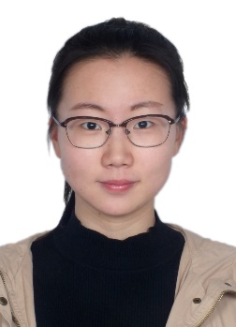
Haoran Chen received her B.S. Degree in applied chemistry from Inner Mongolia University for the Nationalities in 2016. She is currently pursuing her Ph.D. at the Institute of Advanced Materials (IAM), Nanjing Tech University under the supervision of Prof. Yonghua Chen. Her research has focused on low dimensional organic–inorganic hybrid perovskite solar cells.
陈皓然，2016年6月毕业于内蒙古民族大学，获得理学学士学位。现为南京工业大学先进材料研究院博士研究生，在陈永华教授的指导下进行研究。目前主要研究领域为低维有机-无机杂化钙钛矿太阳能电池。

Yonghua Chen received his B.E. degree in chemistry from Inner Mongolia University in 2006 and received his Ph.D. degree in polymer chemistry and physics from the Changchun Institute of Applied Chemistry, Chinese Academy of Sciences, in 2011. After two-year postdoctoral research at Wake Forest University and two-year postdoctoral research at Case Western Reserve University, he is currently a full professor in Nanjing Tech University. His research interests are organic and organic/inorganic hybrid optoelectronic materials and devices, including organic light-emitting diodes and field-induced polymer electroluminescent devices for flat panel displays and solid state lighting, and polymer and perovskite solar cells for energy conversion.
陈永华，南京工业大学先进材料研究院教授、博士研究生导师。2006年7月本科毕业于内蒙古大学化学化工学院，2011年7月在中国科学院长春应用化学研究所高分子化学与物理专业取得博士学位，2011—2015年分别在美国维克森林大学和凯斯西储大学进行博士后研究工作。2015年12月回国后，先后入选第十四批江苏省六大人才高峰、第六批江苏省特聘教授和第十三批“千人计划”青年项目。主要从事有机光电子材料与器件的研究工作。近年来，在有机光电子材料与器件领域发表论文50余篇，包括Nature Communications、Advanced Materials、Light：Science & Applications、Nano Letters、Angewandte Chemie International Edition和Advanced Functional Materials等。

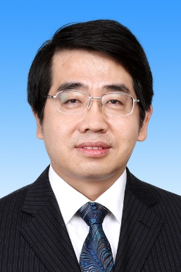
Wei Huang received his B.S., M.S., and Ph.D. degrees in Chemistry from Peking University in 1983, 1988, and 1992, respectively. In 2001, he became a chair professor at Fudan University, where he founded the Institute of Advanced Materials (IAM). In June 2006, he was appointed as the Deputy President of Nanjing University of Posts and Telecommunications. In July 2012, he was appointed as the President of Nanjing University of Technology. In June 2017, he was appointed as the Deputy President of Northwestern Polytechnical University. He is a member of the Chinese Academy of Sciences. His research interests include organic optoelectronics, nanomaterials, polymer chemistry, plastic electronics, and bioelectronics.
黄维，中国科学院院士，俄罗斯科学院外籍院士、名誉博士，西北工业大学常务副校长，教授，博士研究生导师，有机电子学/柔性电子学家。教育部“长江学者”特聘教授，国家杰出青年科学基金获得者，中组部“千人计划”国家特聘专家，科技部“973”项目首席科学家。英国谢菲尔德大学名誉博士，英国皇家化学学会会士，美国光学学会会士，中国科协常委，中国化学会副理事长，中国化工学会副理事长，江苏省科协副主席，江苏省侨联副主席，Advanced Materials、Advanced Electronic Materials和npj Flexible Electronics等国际权威学术杂志主编或（顾问）编委。长期从事有机光电、柔性电子等相关领域的研究，并取得了大量系统性、创新性的研究成果，以第一或通讯作者身份在Nature Materials、Nature Photonics、Nature Nanotechnology、Nature Communications、Advanced Materials、Journal of the American Chemical Society等SCI学术期刊发表研究论文560余篇，获授权或公开美国、新加坡和中国等国发明专利200余项，出版了《有机电子学》、《生物光电子学》等学术专著。曾获国家自然科学奖二等奖和何梁何利基金科技进步奖等奖励，成果入围中国高等学校十大科技进展。

